LAB

REPORT

CSE 114 : Data Structure and Algorithms Sessional

|  |  |
| --- | --- |
| PREPARED BY  Mehrin Farzana  ID: 2101013  Session: 2021-2022  Date: 23/08/2023 | SUPERVISED BY  Suman Saha  Lecturer  Department of IRE, BDU |

|  |  |
| --- | --- |
| logo1 | BANGABANDHU SHEIKH MUJIBUR RAHMAN DIGITAL UNIVERSITY  (BDU) |
|  |  |

**List of Problems**

1. Suppose you are given a sorted linked list. Take input from the user and insert it into the linked list maintaining the particular order.
2. Suppose you are given a sorted linked list. Take input from the user. If the input matches with any item on the list, delete it otherwise print the item not found.

**Problem No.:** 01

**Problem Statement:**

Suppose you are given a sorted linked list. Take input from the user and insert it into the linked list maintaining the particular order.

**Code:**

#include <stdio.h>

#include <stdlib.h>

struct node{

int data;

struct node *next;

};

int main() {

int n,i;

printf("Initial number of elements: ");

scanf("%d", &n);

struct node a[n], *j, *k, input;

printf("Elements: ");

for(i=0; i<n; i++){

scanf("%d", &a[i].data);

if(i>0){

a[i-1].next=&a[i];

}

}

a[i-1].next=NULL;

printf("Data to be inserted: ");

k=&a[0];

scanf("%d", &input.data);

for(j=k; j!=NULL; j=j->next){

if(input.data>=j->data && input.data<=j->next->data){

input.next=j->next;

j->next=&input;

break;

}

else if(input.data<a[0].data){

input.next=k;

k=&input;

break;

}

else if(input.data>a[n-1].data){

a[n-1].next=&input;

input.next=NULL;

break;

}

}

printf("Final list: ");

for(j=k; j!=NULL; j=j->next){

printf("%d ", j->data);

}

return 0;

}

**Output:**

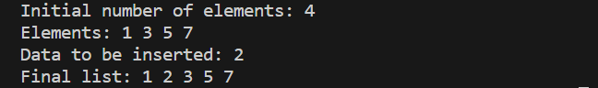

Fig 1.1: Output on console for case 1.

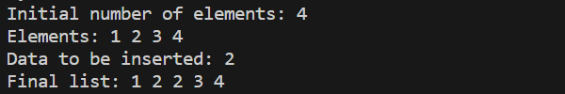

Fig 1.2: Output on console for case 2.

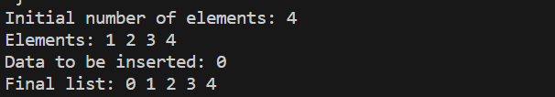

Fig 1.3: Output on console for case 3.

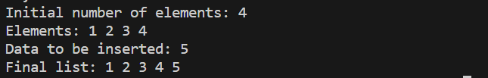

Fig 1.4: Output on console for case 4.

**Problem No.:** 02

**Problem Statement:**

Suppose you are given a sorted linked list. Take input from the user. If the input matches with any item on the list, delete it otherwise print the item not found.

**Code:**

#include <stdio.h>

#include <stdlib.h>

struct node{

int data;

struct node *next;

};

int main() {

int n,i, input,flag=0;

printf("Initial number of elements: ");

scanf("%d", &n);

struct node a[n], *j, *k;

printf("Elements: ");

for(i=0; i<n; i++){

scanf("%d", &a[i].data);

if(i>0){

a[i-1].next=&a[i];

}

}

a[i-1].next=NULL;

printf("Data to be deleted: ");

k=&a[0];

scanf("%d", &input);

for(j=k; j->next!=NULL; j=j->next){

if(input==j->next->data){

j->next=j->next->next;

flag=1;

break;

}

else if(input==a[0].data){

k=a[0].next;

flag=1;

break;

}

}

if(!flag)

printf("Item not found.\n");

printf("Final list: ");

for(j=k; j!=NULL; j=j->next){

printf("%d ", j->data);

}

return 0;

}

**Output:**

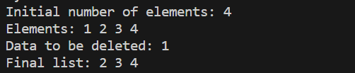

Fig 1.1: Output on console for case 1.

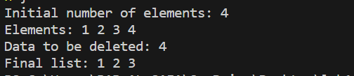

Fig 1.2: Output on console for case 2.

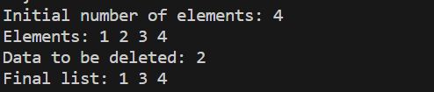

Fig 1.3: Output on console for case 3.

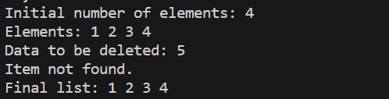

Fig 1.4: Output on console for case 4.